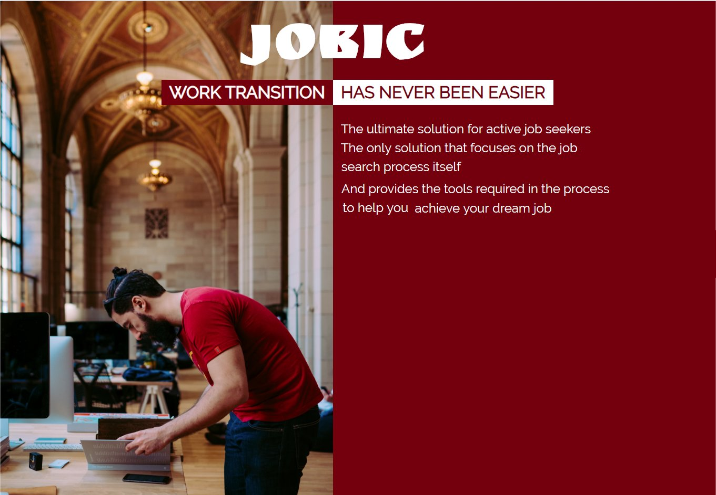


Leiba cohen Ariela
We Work for you

- Introduction
  - Site suggestion:
  - The problem we are solving
  - The value we suggest
  - Our competitive advantage
- preliminary research
  - The content world of the suggested product
  - Is there a real problem?
  - Are there any existing solutions for that problem? And are they good enough?
- Defining the Users, their needs and motivations
  - Target Users
  - Users Needs and motivation
  - What defines success
  - Business goals
  - Personas

- User Stories
- Use Cases
- Entities
- Information System Tree
- Mockups
- Screens
- Axure Link : https://wcgh23.axshare.com

Introduction:

Company name: Jobic
vision: Streamline the job search process
Goal: In 5 years Jobic will be the favorite Add-on plugin for job search platform

Site suggestion:
A job seeker application that provides various tools to streamline the search process

The problem we are solving
A Job seeker in the Israeli Hi-Tech market is flooded with Job interview on one hand and has little time on the other hand, he needs a reliable tool to be able to manage his resources and make the best of his time
Today, all the Job Hunt sites provide a poor solution for the job hunt process itself and offer insufficient solution for tracking the Interviews\offers\ CV sent procedures that are essential in the job hunt process

The value we suggest
A solution that focuses on the job search process itself and provides the user with the tools required in the process to get the best job offer for him

Our competitive advantage
Providing an overall solution for the process side

Preliminary Research

In the research I checked the following aspects:
- The content world of the suggested product
- Is there a real problem?
- Are there any existing solutions for that problem? And are they good enough?

Research results:

- The content world of the suggested product
To learn about the content world of the suggested product I conducted a search online to see what are the popular web sites / application/Tools that provides a solution for an Israeli hi-tech job searcher, is there one leading site that most job searchers prefer.
I discovered that there are lot of web sites / application that apply to a job seeker and there is no "one site" that dominates the market and most of the people use.
I study the following (partial list) :

Web Sites:
https://www.alljobs.co.il/
https://www.drushim.co.il/
https://www.jobnet.co.il/
https://www.jobmaster.co.il/
https://www.linkedin.com/feed/?trk=
https://il.indeed.com/?r=us
https://www.ziprecruiter.com/

Applications:
ICV

Other platforms:
Facebook

Analysis:
Most of these sites and applications focus on posting job offers, offering details about the offer, and sending resumes directly from the application.
In most of them, there is also a designated area for defining and managing the user profile.
In the user profile area, the user can:
- specify parameters for his search, such as desirable positions, preferred employment area, salary, and much more.
- Upload and manage his relevant resume files,
- Keep track on job application he made in the specific application

Conclusions:
- There are lots of web sites that address a job seeker
- A specific web site may offer resume sending services, but only to his site
- The resume send tracking is restricted to sending the user application to specific jobs, there is no way to track a job process over time
- There is no easy way to evaluate if the user job seek is "effective"

- Is there a real problem?
To answer that I conducted a survey

Participants:
- Random people in Sharona Market on a Wednesday night
- Active Job seekers in the UX course
- Active Job seekers from a development course
- Not active job seekers from the Israeli hi-tech world (done frontal and by phone)

The Questions were:
- Are you an active job seeker?
- How do you conduct you search?
- do you use specific web sites / applications? which one
- which one?
- Do you send resume through web sites and through personal email?
- What files / text do you send to a apply for a specific job
- Do you have more than one resume version?
- Do you have more than one cover letter version?
- Do you send more files?
- Do you truck (save) that CV files you are sending? do you save to which company you send? what you send and when?
- How much time passes usually between Job process stages ibn your case?
- Do you have more than one active Job process at a specific time?
- How many steps can be in a job application process?
- How do you track your active job process?
- Do you need a tool to help you manage your job hunt better ?

Analysis:
- There is a difference between Junior (young) Job seekers and a more experienced one.
- Most of the Junior (young) Job seekers:
    - has one resume file
    - have one cover letter file (or none)
    - have a rich portfolio files (from projects at school)
    - portfolio files are popular in creative jobs and less in development jobs
- Most of the experienced Job seekers:
    - have more than one resume
    - have more have more than one cover letter version
    - Portfolio file will hold links to actual products
- People did not have a specific site they use, they just use the site that offered them the desired job opportunity
- People do not use the profile section that the sites offer because its specific to a site
- People use word files to documents their search
- Half the people like to save and record what CV they sent to which job
- Most people can have more than one active job process at the same time
- Job process can hold several steps, mostly more than 4 and less than 10.
- Job process steps can be remote (in time) from one another – sometimes 2 weeks and more apart (specifically in you need security clearance).

Conclusions:
- People use many platforms to apply to a job, they don’t have a strong preference to a specific platform
- People cannot track all resume, cover letter and portfolio files and version from one place
- people use word document to trach their job processes

- Are there any existing solutions for that problem? And are they good enough?
I could not find a good solution for that problem in the existing products on the market , people are not aware of a better way to track their Job process and rely on an updated technology to keep track on there search ( word files )

Defining the Users, their needs and motivations

Target Users
An active job seeker – male/female ages 30-60 that are actively looking for a job in the Israeli hi-tech scene

Users Needs and motivation:
- Find the best available job for him
- Not to lose employment opportunities just because of lack of attention and follow-up
- Do not make embarrassing mistakes in the job search process (such as sending different versions of resumes to the same position)
- Stay in control of long-term screening and hiring procedures
- use crowd wisdom to be more prepared for specific job interview
- A way to see if he is "effective" in his search and if something needs to be changed

What defines success:
- in one years 5 main Israeli Job search sites will offer Jobic solution embedded in their sites
- Jobic users find a job faster than non Jobic users
- Jobic users will feel they have more control on their Job hunt process, they do not loose opportunities any more

Business goals:
- Achieving cooperation agreements with five major sites in the Israeli market
- Obtaining advertising contracts
- Sale services and advanced content to paying users (premium)

Persona:
A Job seeker

- Amir , Age 39 , Full Stack Developer and Team Leader , currently unemployed because his startup company was closed last month Surprisingly, actively looking for a job as team leader or full stack development , whatever comes first and pay more .
he has 4 types of resume files, one for full stack developer in English, second as a team leader in English, and 2 more resumes are translation of that documents to Hebrew (if the job was published in Hebrew , he will send the Hebrew version )

- Shanit ,Age 32 , graphic designer , currently working in a place that she don’t like any more , she wants to look for a job discreetly because she don't want her present employers to know she wants to leave , she must pay close attention to whom she sends her application ( because her Boss have many connections in the market ). She has two resume files one in English and one in Hebrew but she likes to use different cover letters when she appeal for different job applications

User Stories:

Job seeker
- As an active job seeker, I want to be able to track my job interviews details and follow-ups interviews so that I can gain better control on active process, and be prepared

- As an active job seeker, I want to keep track all the places I send my CV and their replies to so that I will not miss employment opportunities on the one hand, and I will not be desperate to send a CV several times to the same position

- As an active job seeker, I want to obtain the maximum information on a company and what they ask before a job interview so that I can maximize my chances to get the job

- As an active job seeker, I want to be able to consult with other active Job seekers so that I will be have better idea if this is a company I like to work in

HR recruiters

- As an HR recruiter I want to be able to contact an active Job seeker so I can offer him a Job
- As an HR recruiter I want to view an active Job seeker profile so I can offer him a Job from my list

Use Cases:
Active Job Seeker profile:
- User Login \ Signup to his account
- User Creates a personal Job seeker profile, expose relevant information about his Job search:
- User Name
- Job title
- experience and expertise
- links to public profiles
- Add CV file \ files (user may have more than one CV file)
- Add Cover Letter \ Letters (user may have more than one cover letter file)
- User Can Manage the process of sending CV - CV tracking system:
Add a company he sends to including these details:
- Company name
- Company Site
- Employees Number
- Location
- email address,
- the source\link of this job (Facebook/job hunt sites / friends, company site / newspaper)

When Sending CV to a company – add a "Send" entity with the following:
- Link to Company entity
- Link To CV version Sent
- Link to Cover letter Sent
- Specify the Suggested Role
- Add the date
- Add Email
- Add Description or comments

- Start a Job process – in case the user heard back from the company he needs to start a work process with the following details:
- Company (name of id)
- To which Job title
- Contact Person
- Link to CV version that was sent
- And some description if needed

If an Interview was organized (phone call or in person) he Adds an Interview with the following details:
- Type (phone/video/in person/home task)
- Meet with
- His Job Title
- Schedule time
- Location
- Contact person (the one that set up the meeting)
- Purpose (meet with HR – professional interview etc.)
- Description (if needed)
- Summary – will be updated at the end of the meeting

- When there is a follow-up interview – User will add more new interviews to the same Job Process.
- User need the ability to Close and Interview branch:
- Status filed indicate if this Job process is active or not
- If the status will change to close – need to add the closing Reason

- Ability to monitor all the active processes and CV sending status using Dashboards on the main page

- View and add " Questions from job interviews" (community/forum) so users can share their knowledge on the questioned being asked in specific company:
- Link Question to company
- Ability to add a question
- Ability to add a solution to a question (there could be mote then one solution)
- Ability to add comment to a solution
- Search option (different filters: by company \ by subject etc.)
- Link to job hunt sites (maybe get data from them?)

- Create a smart agent on a company on a job hunt sites – so if a Job I desire will pop up I will get notification.

HR recruiters
Need to be done ….

Information System Tree
Home Page
Sign In/
Sign Up

User Profile
Dashboard
Interview Question
Forum
Companies
Job Process
Resumes, Cover Letters, Portfolio Versions
Mockups
Live in Axure https://wcgh23.axshare.com

Home / Landing Page
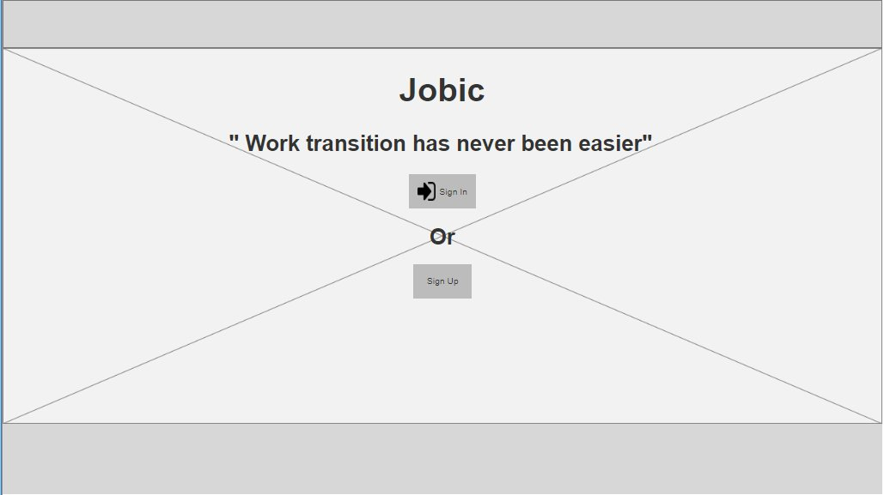

Registration Form
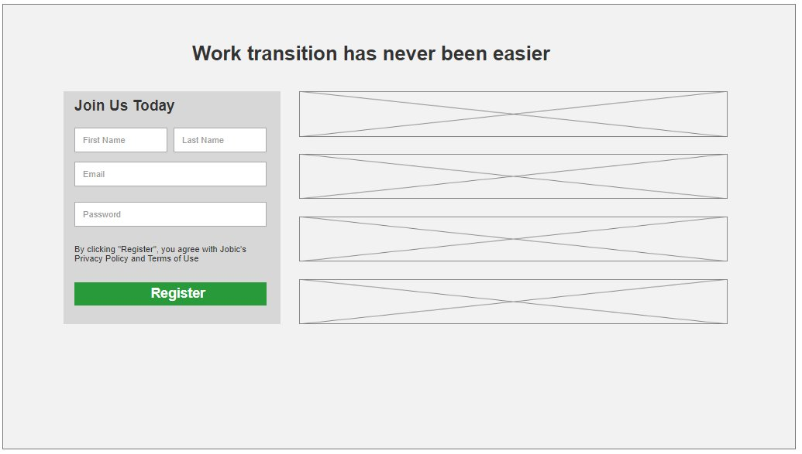

Dashboard

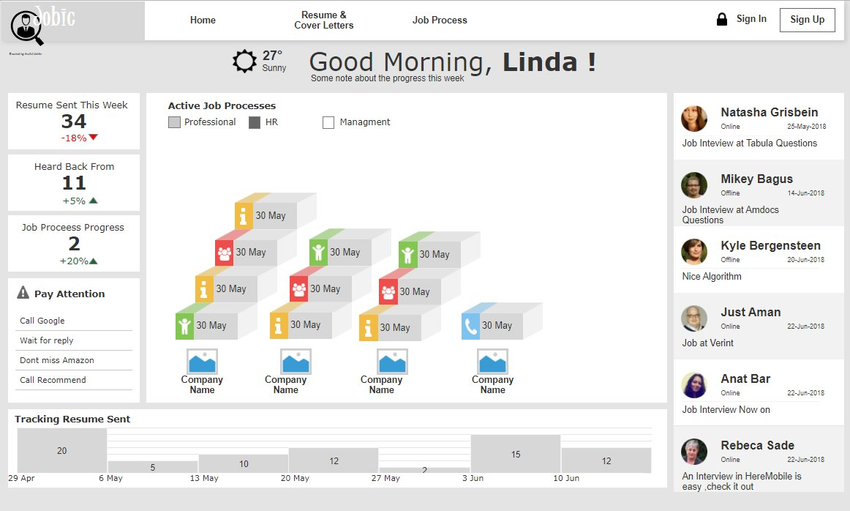

Screens:
Register
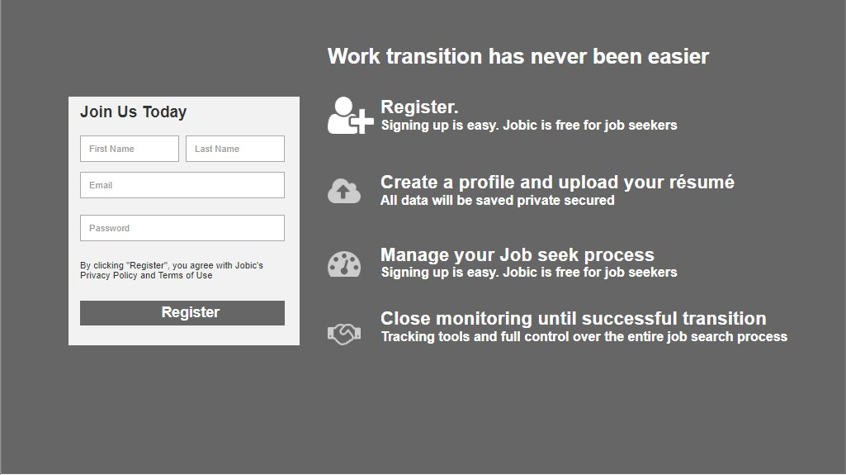

User profile Page

Appendix 1

What are we aiming for
What will we do at each stage
What are we not going to do

Marked research:
In Israel Hi-tech job hunt ' the following application provide solutions:
looking in Israeli web sites :
https://www.alljobs.co.il/
https://www.drushim.co.il/
https://www.jobnet.co.il/
https://www.jobmaster.co.il/
https://www.linkedin.com/feed/?trk=
https://www.geticv.com/
https://www.thebalancecareers.com/best-job-search-engine-sites-2061906
https://www.careerbuilder.com/
https://www.dice.com/
https://il.indeed.com/?r=us
https://www.idealist.org/en/?type=JOB
https://www.monster.com/
https://www.ziprecruiter.com/

list taken from :
https://www.thebalancecareers.com/top-best-job-websites-2064080

https://helpdesk.thrivist.com/hc/en-us/articles/226493928-What-Information-is-on-My-Learner-Dashboard-
https://dribbble.com/shots/2859111-Dashboard-Template-work-in-progress

https://www.dice.com/register - registration

Business model (where the money will come from)
- Banner ads
- Add-Free solutions
- Freeminum

Working version Live

https://arielaleco.github.io/Jobic/

Company
Company ID
Name
Domain
Location
Description
Web Site
Employees No.

Job Process
Process ID
Company ID
Job Title
Contact person
Description
CV Version
Status
Reason
Interviews List

Interview Question
Question No.
Company ID
To Role
Date
Title
The question
Author (User)
Solutions List

User Profile
Name
Login
Password
List of Expertise
List of Searches
Location
Location
List Of public profiles
List of Job Processes

Interview
Interview No.
Type
Meet With
Job Title
Location
schedule time
Contact person
Purpose
Description
Summary

Interview Question
Question No.
Company ID
To Role
Date
Title
The question
Author (User)
Solutions List

CV Sent
Company
CV Version
Opening letter\Cover Letter

Material
Material No.
Description
Source
File\Link

CV Versions
CV Version
To Job Title
Description
File

Cover Letter
Cover Letter No.
To Job Title
Description
File

CV Sent
Company ID
CV Version
Cover Letter No.
Date
To Role
Link To Source
Email
Description

Solution
Solution No.
Question No.
Linked To Solution No.
Author
Solution
Comments

